**Name:Salma Rani**

**Sap ID:54194**

**Course:Computer Architecture Lab**

**Instructor Name:Mam Ayesha**

**Task 1:**

**Case 1:**

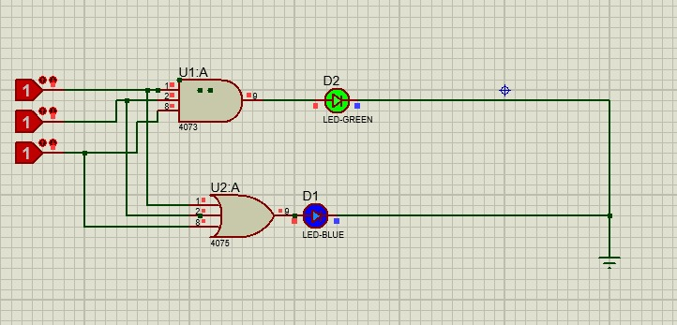

**Case 2:**

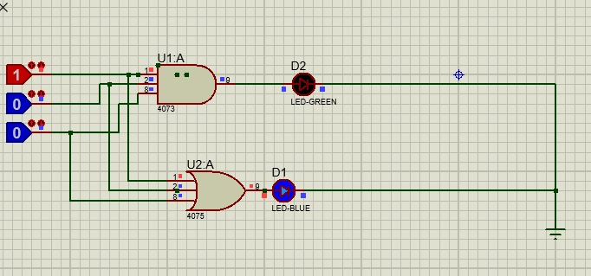

**Task 2:**

**Case 1:**

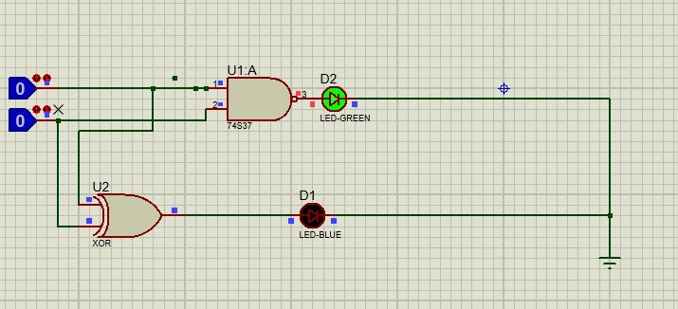

**Case 2:**

